WatchX Network is a Web3 ecosystem built upon wearables. By promoting active health, providing convenience and offerring multiple incentives to wearable device users, driving high-quality mass adoption of Web3.

**Join WatchX for exclusively Whitelist**

🐦Follow @watchxnetwork

👾Join https://discord.gg/rBM9BCzTpF  
✈️Join <https://t.me/watchxofficial>

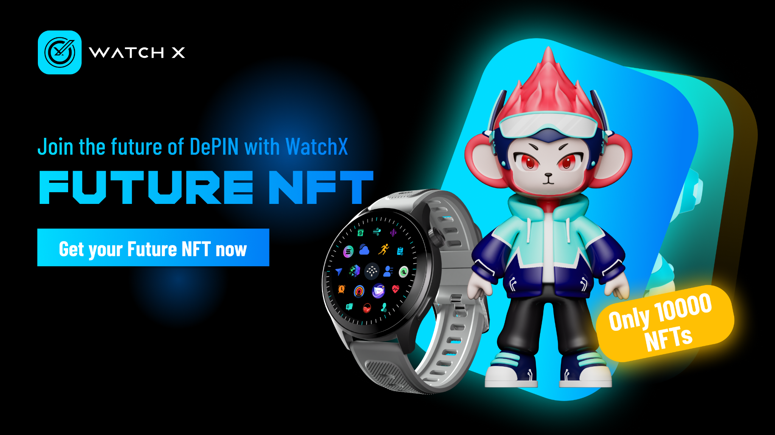

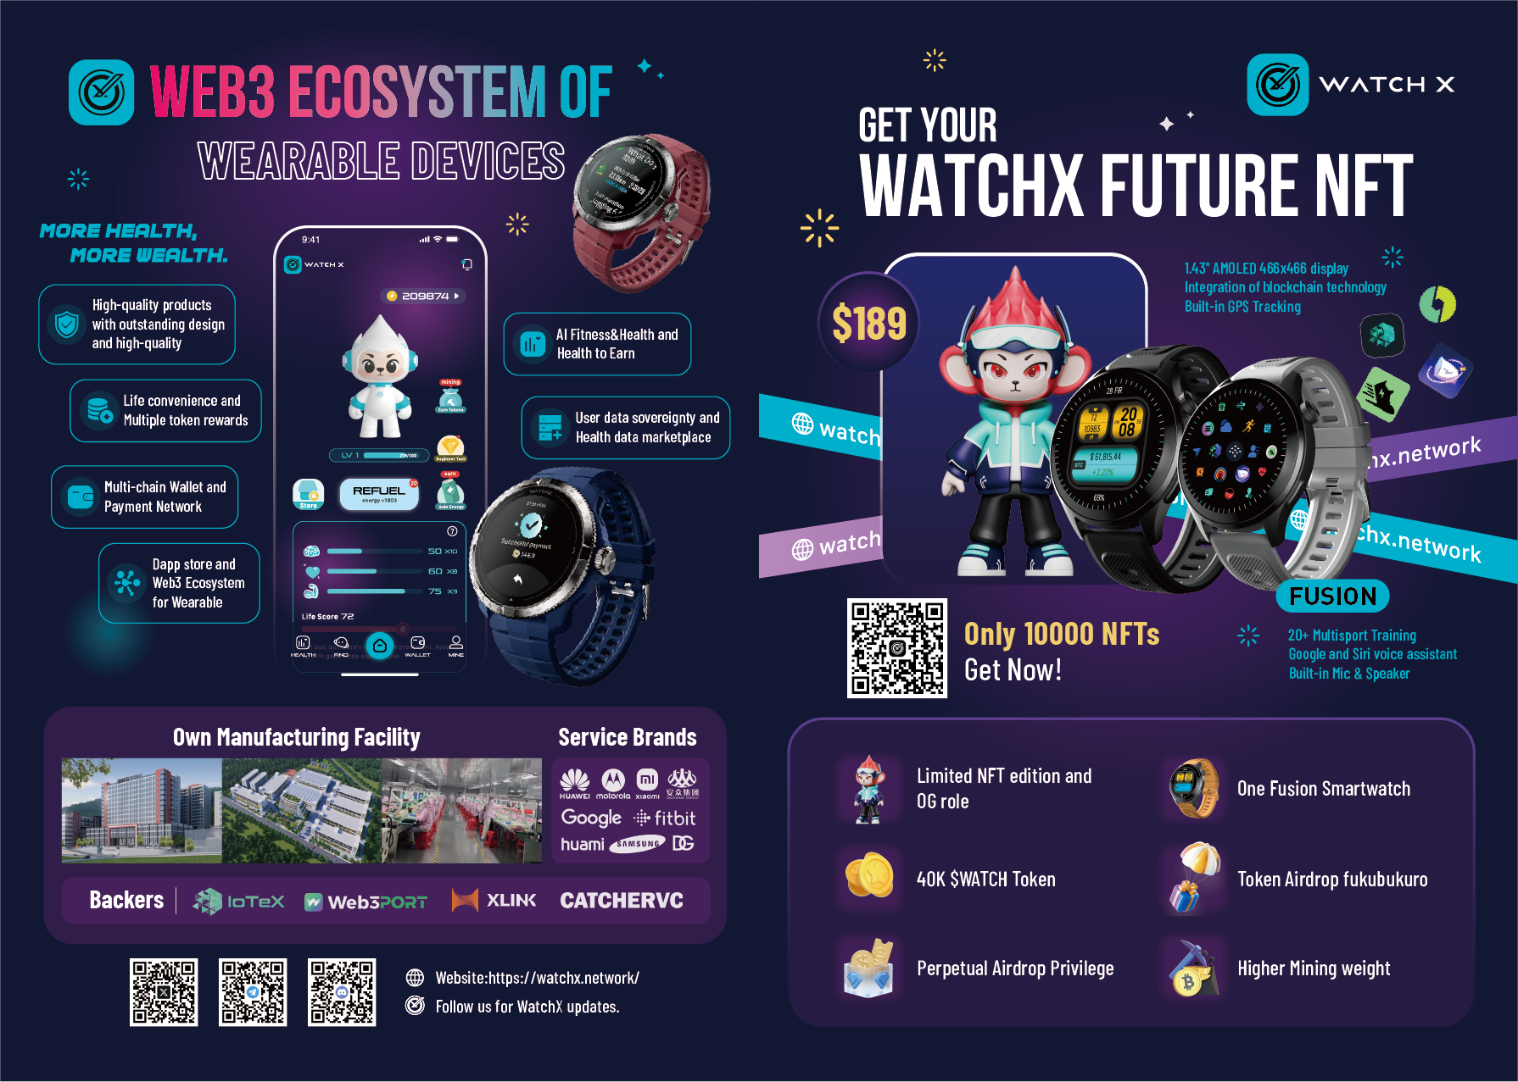

🚀 **WatchX Future**

Launching as a NFT gift package,WatchX NFT holders will receive multiple benefits for users experiencing the earliest Web3 wearable to a new digital lifestyle.🌐🔗

⌚️ High-quality WatchX Fusion series smartwatch

🪂 Permanent Token airdrops from $WATCH & Partners  
💰 Multiple token rewards for everyday use & Higher Mining weight

🎉 IoTeX io.ID for Wear-to-Earn in Web3

Stunning Web3 smartwatch integrates with the blockchain dApps offering convenient solutions for daily activities.   
💳 Multi-chain wallet & payment network

📱 Dapp store & Web3 ecosystem for wearables

🤖 AI-driven fitness & health monitoring

🏃‍♂️ Health to Earn: turn fitness into rewards

🔐 User data sovereignty & health data marketplace

Within our ecosystem, the smartwatches are equipped with a multi-chain wallet, AI HealthFi and other dApps, operating as a management hub. It identifies biometric data and distributes rewards efficiently for completed tasks and secure payment transactions. By leveraging blockchain rewards, WatchX delivers unparalleled Web3 experiences to millions of users worldwide through our wearable devices.

WatchX smartwatch can directly interact with blockchain networks, support decentralized applications (dApps) deployment on the web3 smartwatch, and ensure the security and privacy of user data. Users can perform cryptocurrency payments, identity verification, and data sharing directly from the watch, with full control over their data ownership and usage rights, while also earning various Web3 rewards.

Our first web3 smartwatch will deliver on Sep 20 2024, it introduces users to a new digital lifestyle, offering secure and convenient solutions for daily activities and life convenience such as health monitoring, payments, and identity verification.